First, let’s create a volume to save the Java application with:
docker volume create java-vol

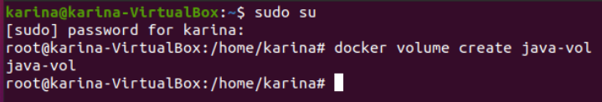

docker volume create java-vol :

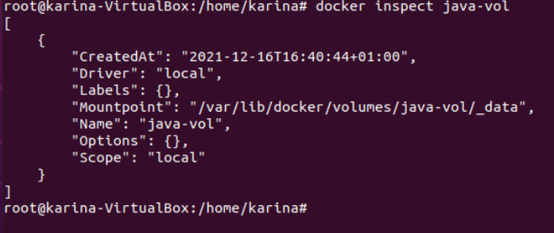
Then we create a java doc:

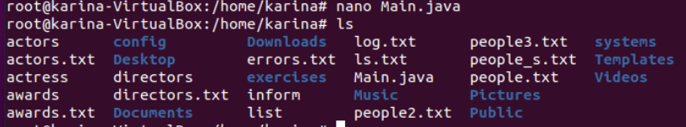
Then copy the java file into:

Then the commands:
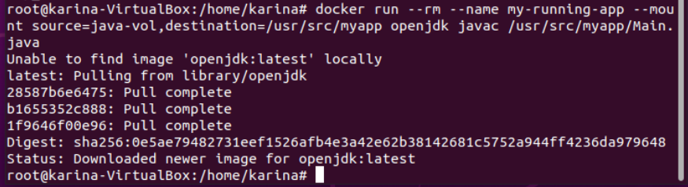

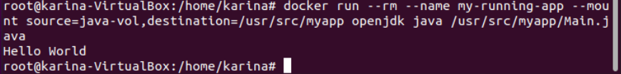
And then the bash commands:
